Implementation of 2016/17 Laws of the Game

Background
For the first time, the Laws of the Game will be published by IFAB, the International Football Association Board, the organization responsible for updating the Laws for many years. This means the IFAB logo – and not the FIFA logo – will be featured on the cover.
This is the result of IFAB being formed as a legal entity separate and apart from FIFA. IFAB exists solely for the purpose of setting the Laws of the Game.
The Laws had not seen a comprehensive rewrite in many years. IFAB selected retired English referee David Elleray (pictured above) to oversee the rewrite. Among other goals, Elleray has said the rewrite should make the laws “clearer” and less subject to contradicting interpretation.

Administrative Changes
Until now, the Laws were actually two separate publications: the Laws “proper” and a separate section called “Interpretation of the Laws of the Game and Guidelines for Referees”, or simply “The Interpretations” to most referees. Under the rewrite, these two separate sections are merged into a single publication. Interpretations are discussed within each Law itself.
Referees in the USA may be familiar with this approach, as it has been utilized for years in the NCAA and the NFHS Soccer Rules publications (both of which vary to some extent from the LOTG).
The Laws will now be gender neutral. Instead of using only masculine pronouns, the revised Laws use language that does not refer to one gender.
The Laws will be much briefer. In the current edition of the Laws and Interpretations, the document clocks in at over 20,000 words. The revised Laws will be about 10,000 words.

CHANGE 1: Kick-off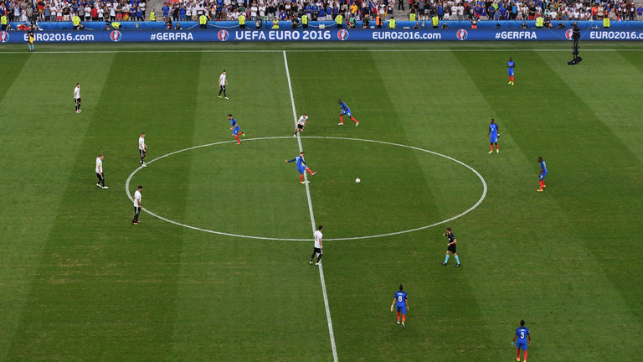
The kick-off restart can now go backwards.

As seen at Euro 2016, the ball no longer has to go forward at kick-off. The previous law stated the ball had to go into the opposition half at the restart, but it has been changed to allow it to move in any direction, as long as it "clearly moves". This change has paved the way for one-man kick-offs, as seen at Euro 2016.

CHANGE 2: Pre-match red cards
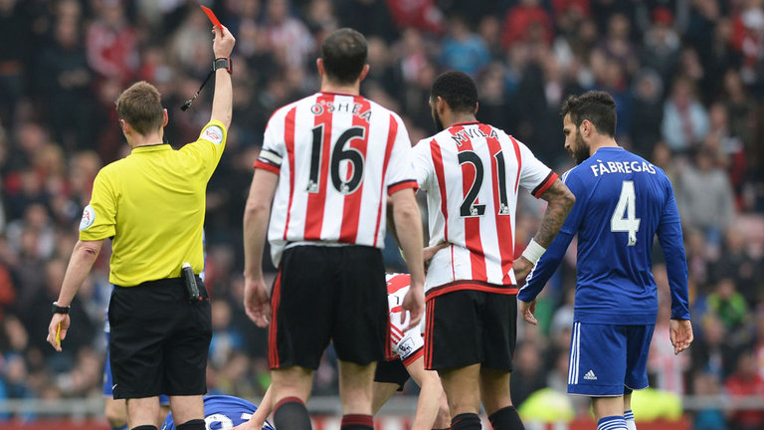
It will now be possible to get a red card before the match starts.

Referees will be able to give a player a red card before the match kicks off. This allows officials to punish red-card offences (e.g. violent conduct) in the warm-up or as the two teams line up in the tunnel. The new law states a player may be sent off any time between the pre-match inspection and when the referee leaves the field at the end of the game.

CHANGE 3: An end to the 'triple-punishment law'
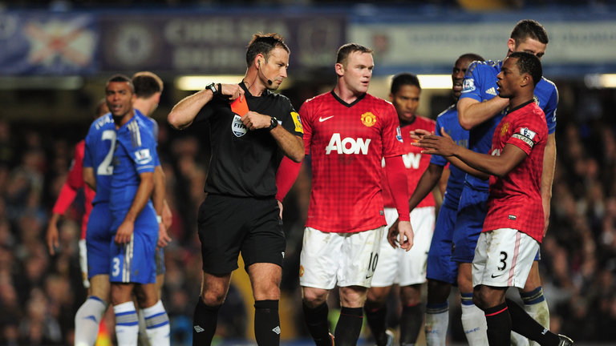
Players may only receive a yellow card if they concede a penalty
The previous 'triple-punishment' law meant a player who denied a goal-scoring opportunity in the box was automatically red-carded and handed a suspension, as well as giving away a penalty.
The law has now been changed so players committing accidental fouls that deny goal-scoring opportunities in the penalty area will not be automatically sent off, with a yellow card sufficient punishment.
As the amendment states: "When a denial of a goal scoring opportunity offence is committed by a defender in the penalty area, the penalty kick effectively restores the goal scoring opportunity so the punishment for the player should be less strong (e.g. a yellow card) than when the offence is committed outside the penalty area. However, when the offence is handball or clearly not a genuine attempt to play or challenge for the ball, the player will be sent off."

CHANGE 4: Treating injuries
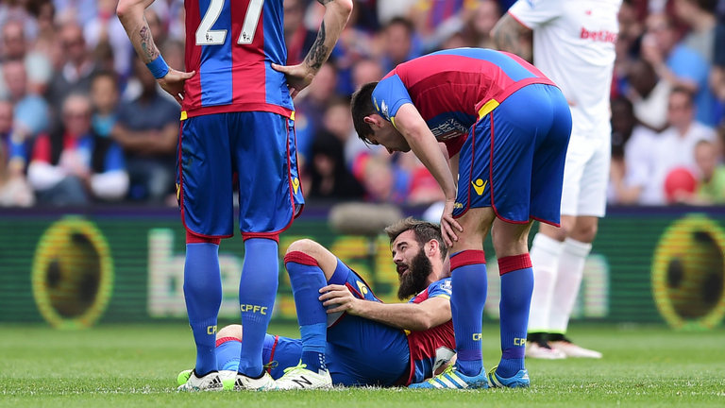
Players will be able to receive treatment quickly on the pitch if they are injured in a challenge that results in a yellow or red card.
If a player is fouled and hurt by an opponent who subsequently receives a yellow or red card for the challenge, the injured player may be quickly treated on the pitch without the need to leave the field of play.
It was widely seen as unfair that a player injured by a serious foul was forced off the pitch for treatment, temporarily placing the fouled team at a numerical disadvantage.

CHANGE 5: Changing boots/equipment
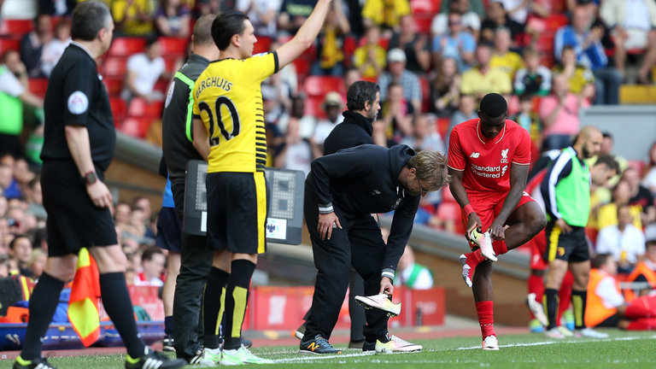
Assistant referees or fourth officials will be able to check players before they return to the pitch.
A player who briefly leaves the field (e.g. to change boots) may have his new boots checked by an assistant referee or fourth official before returning to play.
Previously, the player required the referee's permission to return.

CHANGE 6: Penalties

Penalties: “Feinting once the run-up is complete will result in a yellow card for the taker.” Among several minor changes to the laws regarding penalties, potentially the most interesting is the amendment to yellow card a penalty taker who "illegally feints" once his run-up is complete. This means slowing to a stop immediately before shooting is not allowed, with a yellow card and an indirect free-kick to the opposition the result.
The law does stress feinting during a run-up is still permitted.
Goalkeepers who come off their line during a penalty kick will be cautioned if the kick fails, in addition to the kick being re-taken
If the kicker of the penalty kick violates the Laws, the kick will no longer be retaken and play will be restarted with an indirect free kick for the defending team.

CHANGE 7: Infringements by substitutes/team officials

Diego Simeone watched much of Atletico Madrid's win over Malaga from the stand after he was sent off.
Atletico Madrid boss Diego Simeone was sent to the stands in April after a member of his backroom team threw a ball onto the pitch during a La Liga game in an attempt to interrupt an opponent's attack. To address what was threatening to become a growing trend, the law has been changed so that if play is stopped due to interference from a team official or substitute, rather than the award of an indirect free-kick or drop ball, the referee will now award a free-kick or penalty kick to the opposition.

CHANGE 8: Colour of undergarments

Hector Bellerin's undershorts are the same colour as his shorts.
The new rule states undershorts/tights must be the same colour as the main colour of the shorts or the lowest part of the shorts. This takes into account shorts with a different coloured hem.

Undershirts must still be the same colour as the main colour of the shirt sleeve.

CHANGE 9: Offside
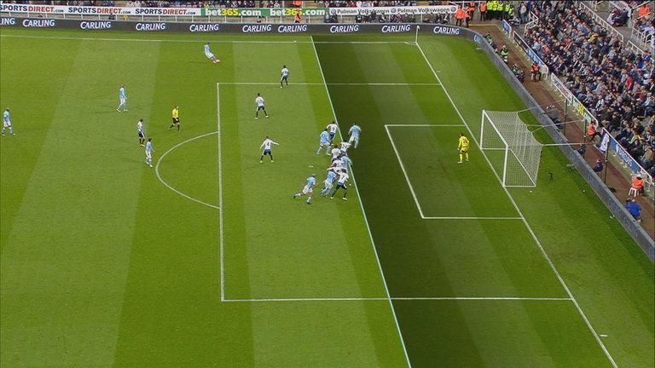
The offside rule has once again been clarified.
A couple of minor clarifications to the offside rule. The law now states the halfway line is neutral, meaning a player must have part of the body (excluding arms or hands) in the opponents' half to be flagged offside.

A free-kick resulting from an offside will now always take place where the offence is committed.
Offside restarts will be taken from the point on the field where the offending player was when they became offside. Under the current Laws, the restart would be taken from the point where they were originally in an offside position. (Editor’s note: it will be interesting to see how the Assistant Referee mechanics might be updated to handle a situation where a player starts a play from an offside position in the attacking half of the field and then becomes involved in active play on the defending half of the field).

CHANGE 10: Handballs

Yellow cards will be awarded when handballs prevent a promising attacking opportunity.
In an effort to stop referees brandishing yellow cards for every handball, "preventing an opponent gaining possession" has been removed from the list of bookable offences.

Handball is now a yellow card offence when "it stops/interferes with a promising attack".

CHANGE 11: Restarts

When taking a corner, the ball must clearly move.
The phrase "clearly moves" has been added to the law on restarts, meaning attempts to trick the opposition by lightly tapping the ball at a corner (or free-kick) and then dribbling will come to an end. This amendment is part of a renewed emphasis on what constitutes sporting behavior "within the spirit of the game".

CHANGE 12: Player behavior
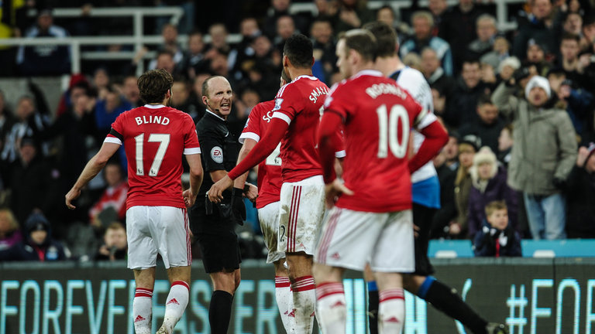
Referees have been asked to clamp down on situations when players contest their decisions.
Referees have been urged to take a stronger stand on "intolerable behaviour" by players following a joint statement by the Premier League, English Football League and FA.

Running to contest decisions, arguing face-to-face with officials, and "visibly disrespectful" actions will result in yellow cards.
Red cards will be issued to players who confront officials and use insulting and/or offensive language or gestures towards them.
The aim is to "reduce disrespectful conduct such as aggressively challenging decisions or running from distance to confront an official."

If opposing players are off the field of play (through the course of normal play) and one commits a foul, play will be restarted with the appropriate free kick, on the touchline or goal line. Under the current Laws, play restarts with a dropped ball, as only misconduct and not fouls can be committed off the field of play. The example given by Mr Elleray to illustrate is when a pair of opponents go off the field during the run of play, and one grabs the other to prevent him/her from re-entering the field of play. The team of the player whose shirt was grabbed will now be awarded a free-kick on the appropriate boundary line. Note that this could result in a penalty kick being awarded.

A complete breakdown of the amendments to the laws of the game can be found at: https://ussoccer.app.box.com/s/ruqcsf0671k1bcf6dzwf/1/7594344289/62354524769/1

The above article was courtesy of https://intheopinionofthereferee.com
And
http://www.skysports.com/

